**Supporting information for:**

Distribution of PAHs, PCBs, and PCDD/Fs in products from the full-scale pyrolysis of diverse contaminated organic waste

*Erlend Sørmo1,2, Katinka M. Krahn3, Gudny Øyre Flatabø4,5, Thomas Hartnik6, Hans Peter H. Arp2,7, Gerard Cornelissen2,3\**

1. Norwegian Geotechnical Institute (NGI), 0484 Oslo, Norway
2. Norwegian University of Life Sciences (NMBU), 1430 Ås, Norway
3. Lindum AS, 3036 Drammen, Norway
4. Scanship AS, Nedre Langgate 19, 3126, Tønsberg, Norway
5. University of South-Eastern Norway (USN), Porsgrunn, Norway
6. Norwegian Institute of Bioeconomy Research (NIBIO), 1433 Ås, Norway
7. Norwegian University of Science and Technology (NTNU), 7491 Trondheim, Norway

*Corresponding author contact details: gerard.cornelissen@ngi.no

Table S.1. PAH, PCDD/F, and PCB congeners analyzed, the respective number of aromatic rings (PAH) or chlorine atoms (PCDD/F and PCB) and toxic equivalency factors (TEF) analyzed in this study.

|  |  |  |  |
| --- | --- | --- | --- |
| **PAH-16** | **Abbreviation** | **Aromatic rings** | **TEF** |
| Naphthalene | Nap | 2 | 0.001 |
| Acenaphthylene | Acy | 3 | 0.001 |
| Acenaphthene | Ace | 3 | 0.001 |
| Fluorene | Flu | 3 | 0.001 |
| Phenanthrene | Phen | 3 | 0.001 |
| Anthracene | Ant | 3 | 0.01 |
| Fluoranthene | Flt | 4 | 0.001 |
| Pyrene | Pyr | 4 | 0.001 |
| Benz(a)anthracene | B(a)A | 4 | 0.1 |
| Chrysene | Cry | 4 | 0.01 |
| Benzo(b)fluoranthene | B(b)F | 5 | 0.1 |
| Benzo(k)fluoranthene | B(k)F | 5 | 0.1 |
| Benzo(a)pyrene | B(a)P | 5 | 1 |
| Indeno(1,2,3-cd)pyrene | IP | 6 | 0.1 |
| Benzo(ghi)perylene | B(ghi)P | 6 | 0.01 |
| Dibenz(ah)anthracene | DB(ah)A | 5 | 1 |
| **PCDD/F-17** | **Abbreviation** | **Chlorines** | **TEF** |
| 2,3,7,8-Tetrachlorodibenzodioxin | 2,3,7,8-TCDD | 4 | 1 |
| 1,2,3,7,8-Pentachlorodibenzodioxin | 1,2,3,7,8-PeCDD | 5 | 1 |
| 1,2,3,4,7,8-Hexachlorodibenxodioxin | 1,2,3,4,7,8-HxCDD | 6 | 0.1 |
| 1,2,3,6,7,8-Hexachlorodibenxodioxin | 1,2,3,6,7,8-HxCDD | 6 | 0.1 |
| 1,2,3,7,8,9-Hexachlorodibenxodioxin | 1,2,3,7,8,9-HxCDD | 6 | 0.1 |
| 1,2,3,4,6,7,8-Heptachlorodibenxodioxin | 1,2,3,4,6,7,8-HpCDD | 7 | 0.01 |
| Octachlorodibenzodioxin | OCDD | 8 | 0.003 |
| 2,3,7,8-Tetrachlorodibenzofuran | 2,3,7,8-TCDF | 4 | 0.1 |
| 1,2,3,7,8-Pentachlorodibenzofuran | 1,2,3,7,8-PeCDF | 5 | 0.05 |
| 2,3,4,7,8-Pentachlorodibenzofuran | 2,3,4,7,8-PeCDF | 5 | 0.5 |
| 1,2,3,4,7,8-Hexachlorodibenzofuran | 1,2,3,4,7,8-HxCDF | 6 | 0.1 |
| 1,2,3,6,7,8-Hexachlorodibenzofuran | 1,2,3,6,7,8-HxCDF | 6 | 0.1 |
| 1,2,3,7,8,9-Hexachlorodibenzofuran | 1,2,3,7,8,9-HxCDF | 6 | 0.1 |
| 2,3,4,6,7,8-Hexachlorodibenzofuran | 2,3,4,6,7,8-HxCDF | 6 | 0.1 |
| 1,2,3,4,6,7,8-Heptachlorodibenzofuran | 1,2,3,4,6,7,8-HpCDF | 7 | 0.01 |
| 1,2,3,4,7,8,9-Heptachlorodibenzofuran | 1,2,3,4,7,8,9-HpCDF | 6 | 0.01 |
| Octachlorodibenzofuran | OCDF | 8 | 0.001 |
| **PCB-7** | **Abbreviation** | **Chlorines** |  |
| 2,4,4'-Trichlorobiphenyl | PCB28 | 3 |  |
| 2,2',5,5'-Tetrachlorobiphenyl | PCB52 | 4 |  |
| 2,2',4,5,5'-Pentachlorobiphenyl | PCB101 | 5 |  |
| 2,2',3,4,4',5'-Hexachlorobiphenyl | PCB138 | 5 |  |
| 2,2',4,4',5,5'-Hexachlorobiphenyl | PCB153 | 6 |  |
| 2,2',3,4,4',5,5'-Heptachlorobiphenyl | PCB180 | 6 |  |
| 2,3',4,4',5-Pentachlorobiphenyl | PCB118 | 7 |  |

Table S.2. Pyrolysis product yields and gas sampling volumes.

|  |  |  |  |  |  |  |  |  |
| --- | --- | --- | --- | --- | --- | --- | --- | --- |
| **Feedstock** | **Pyrolysis temp. (°C)** | **Yield (%)** | | | **Gas sampling volumes** | | | |
| **Biochar** | **Oil** | **Gas** | **V_gas_m3** | **V_gas_m3kg** | **V_gas_m3kg_propane** | **V_gas_m3kg_feedstock** |
| CWC | 500 | 18 % | 31 % | 52 % | 2.3 | 101.2 | 647.5 | 18.3 |
| 600 | 20 % | 32 % | 49 % | 2.3 | 93.2 | 310.9 | 17.8 |
| 700 | 20 % | 27 % | 53 % | 2.3 | 88.9 | 223.7 | 18.0 |
| 750 | 16 % | 13 % | 71 % |  | 120.1 | 303.5 | 17.8 |
| DSS-1 | 500 | 62 % | 21 % | 17 % | 2.1 | 7.6 | 7.6 | 0.6 |
| 600 | 58 % | 22 % | 20 % | 1.6 | 10.3 | 10.3 | 5.0 |
| 700 | 62 % | 22 % | 16 % | 2.4 | 6.7 | 6.7 | 4.6 |
| 800 | 70 % | 21 % | 10 % |  | 3.8 | 3.8 | 5.0 |
| DSS-2 | 500 | 52 % | 28 % | 20 % | 1.5 | 12.6 | 12.6 | 4.7 |
| 600 | 43 % | 25 % | 32 % | 2.3 | 27.6 | 58.8 | 8.8 |
| 700 | 46 % | 38 % | 16 % | 2.3 | 17.8 | 24.2 | 11.4 |
| 800 | 40 % | 31 % | 29 % | 2.1 | 27.0 | 31.9 | 9.0 |
| FWR | 600 | 35 % | 24 % | 41 % | 2.4 | 37.0 | 44.0 | 12.6 |
| 800 | 35 % | 22 % | 43 % | 2.0 | 41.3 | 55.8 | 14.8 |
| GW | 500 | 31 % | 42 % | 27 % | 2.1 | 22.2 | 42.0 | 6.9 |
| 600 | 32 % | 24 % | 44 % |  | 37.6 | 61.5 | 10.2 |
| 800 | 24 % | 23 % | 54 % | 1.3 | 58.0 | 64.0 | 12.1 |
| LSS | 600 | 57 % | 21 % | 22 % | 2.4 | 16.0 | 20.6 | 0.3 |
| 750 | 49 % | 19 % | 32 % | 2.4 | 78.9 | 294.4 | 32.1 |
| WT | 500 | 30 % | 48 % | 22 % | 1.9 | 17.2 | 26.2 | 2.3 |
| 600 | 27 % | 41 % | 32 % | 2.4 | 29.1 | 44.1 | 6.7 |
| 700 | 21 % | 26 % | 53 % | 1.9 | 66.4 | 91.4 | 12.0 |
| 800 | 18 % | 24 % | 58 % | 1.2 | 73.8 | 79.3 | 12.8 |

Table S.3. Total concentration of PAHs, PCDD/Fs and PCBs in feedstock (F) and biochars produced at various temperatures (500-800 ˚C) and European Biochar Certificate (EBC) limit values.

|  |  |  |  |  |  |  |  |  |  |  |  |
| --- | --- | --- | --- | --- | --- | --- | --- | --- | --- | --- | --- |
| **PAHs (mg/kg)** | | | | | | **PCDD/F (ng/kg)** | | | **PCBs (µg/kg)** | | |
|  | **Temp.** | **∑16 EPA PAH** | **∑16 EPA PAH EBC limit** | **∑8 EFSA PAH** | **∑8 EFSA PAH EBC limit** | **∑17 PCDD/F (TEQ)** | **∑PCDD/F EBC limit** | **∑17 PCDD/F** | **∑7 PCB** | **∑PCB EBC limit** | **∑6 PCB EBC limit** |
| DSS-1 | F | 1.48 ± 0.03 | 6 mg/kg DM  for all EBC  products | 0.52 ± 0.01 | 1 mg/kg DM  (4 mg/kg DM for EBC-BasicMaterials) | 8.3 ± 0.4 | 20 ng/kg I-TEQ OMS | 2011 ± 118 | 21 | 200 µg/kg DM | 10 µg TEQ/kg DM |
| 500 | 18 ± 1 | 3.1 ± 0.09 | n.d. | 2.69 | 1.7 |
| 600 | 22 ± 1 | 1.73 ± 0.07 | n.d. | 2.01 | <LOQ |
| 700 | 7 ± 0.3 | 0.25 ± 0.01 | n.d. | 2.58 | 1.3 |
| 800 | 3.7 ± 0.1 | 0.14 ± 0.01 | n.d. | 0.44 | 0.3 |
| DSS-2 | F | 0.5 ± 0.02 | 0.148 ± 0.004 | 1.78 ± 0.04 | 302 ± 6 | 7.6 ± 0.3 |
| 500 | 37 ± 2 | 2.54 ± 0.08 | 0.03 | 3.31 | 0.6 |
| 600 | 22.9 ± 0.5 | 0.83 ± 0.01 | 0.02 | 2.89 | 0.4 |
| 700 | 5.9 ± 0.5 | 0.17 ± 0.01 | 0.03 | 3.15 | 0.4 |
| 800 | 23 ± 1 | 1.02 ± 0.05 | 0.03 | 2.66 | 0.5 |
| FWR | F | 0.38 ± 0.01 | 0.08 ± 0.004 | 1.18 ± 0.05 | 323 ± 14 | 9.2 ± 0.4 |
| 600 | 9.1 ± 0.5 | 0.22 ± 0.01 | 0.1 | 9.5 |  |
| 800 | 6.7 ± 0.3 | 0.2 ± 0.01 | 0.003 | 0.3 |  |
| LSS | F | 0.98 ± 0.03 | 0.39 ± 0.01 | 3 ± 0.1 | 589 ± 29 | 17 ± 1 |
| 600 | 3.38 ± 0.04 | 0.15 ± 0.01 | n.d. | n.d. | 0.3 |
| 750 | 2.7 ± 0.1 | 0.13 ± 0.01 | n.d. | n.d. | 0.2 |
| WT | F | 5 ± 0.1 | 1.08 ± 0.02 |  |  |  |  |  |  |
| 500 | 2.5 ± 0.1 | 0.16 ± 0.01 |  |  |  |  |  |  |
| 600 | 118 ± 5 | 7.46 ± 0.22 |  |  |  |  |  |  |
| 700 | 21 ± 1 | 0.45 ± 0.01 |  |  |  |  |  |  |
| 800 | 5 ± 0.3 | 0.13 ± 0.01 |  |  |  |  |  |  |
| GW | F | 0.89 ± 0.02 | 0.141 ± 0.005 |  |  |  |  |  |  |
| 500 | 14 ± 1 | 0.54 ± 0.02 |  |  |  |  |  |  |
| 600 | 5 ± 0.2 | 0.31 ± 0.01 |  |  |  |  |  |  |
| 800 | 7.1 ± 0.3 | 0.25 ± 0.01 |  |  |  |  |  |  |
| CWC | F | <LOQ | <LOQ |  |  |  |  |  |  |
| 500 | 9.4 ± 2.5 | 0.39 ± 0.08 |  |  |  |  |  |  |
| 600 | 17 ± 5 | 0.56 ± 0.19 |  |  |  |  |  |  |
| 700 | 6.6 ± 3.4 | 0.23 ± 0.09 |  |  |  |  |  |  |
| 750 | 6.4 ± 0.1 | 0.26 ± 0.02 |  |  |  |  |  |  |

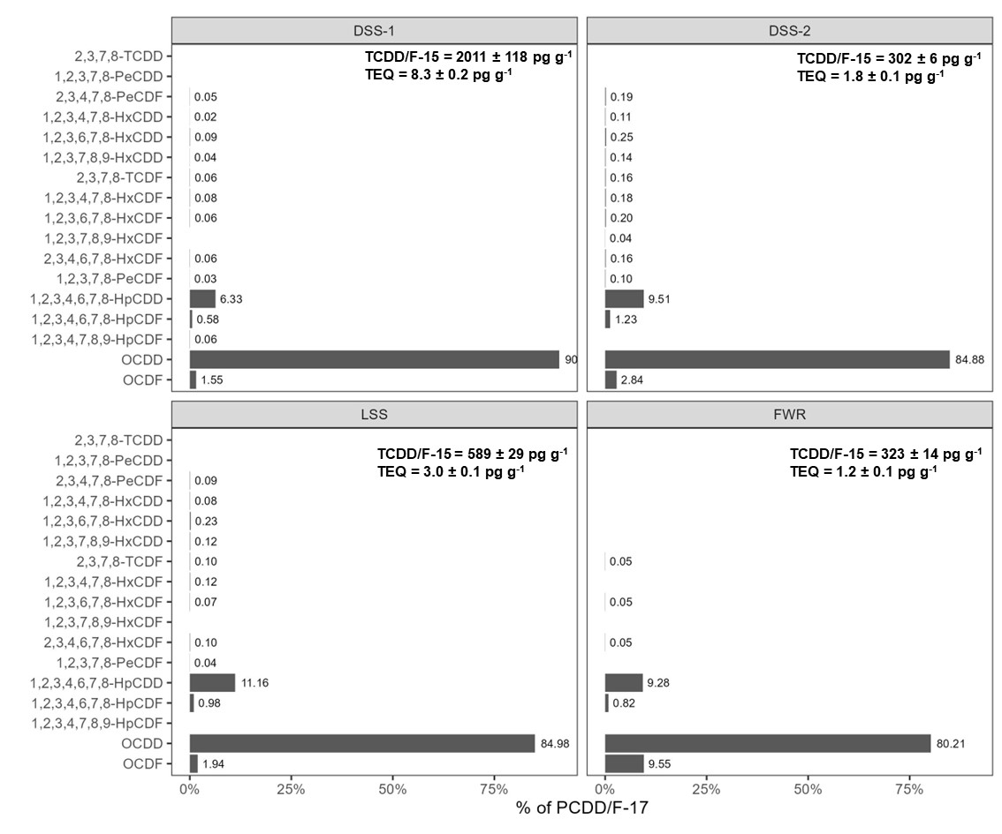

Figure S.1 Total concentration (∑PCDD/F-17, pg g-1), toxic equivalence quotients (TEQ) relative to 2,3,7,8-PCDD, and distribution of dioxins (% of ∑PCDD/F-17) detected in the digested sewage sludges (DSS-1 and DSS-2), limed sewage sludge (LSS), and food waste reject (FWR) prior to pyrolysis, in order of descending TEF.

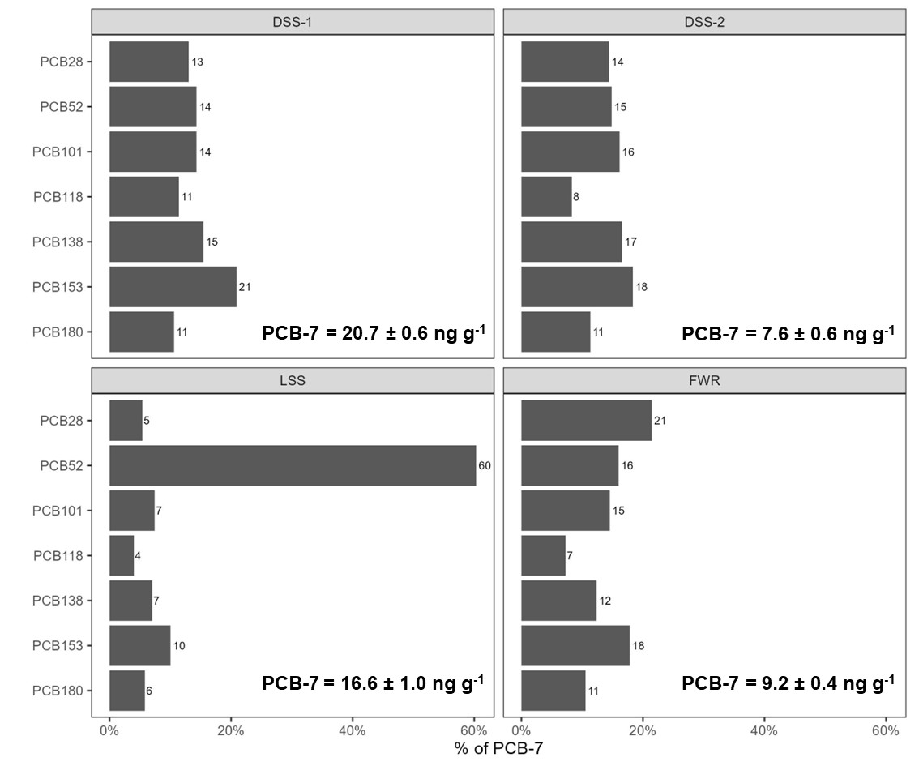

Figure S.2 Total concentration (ng PCB-7 g-1), and distribution of PCBs (% of PCB-7) detected in the digested sewage sludges (DSS-1 and DSS-2), limed sewage sludge (LSS), and food waste reject (FWR) prior to pyrolysis.

Figure S.3 Total concentration (∑PAH-16 µg g-1), toxic equivalence quotients (TEQ) relative to B(a)P, and distribution of PAHs (% of ∑PAH-16) detected in the digested sewage sludges (DSS-1 and DSS-2), dewatered sewage sludge (DWSS), limed sewage sludge (LSS), food waste reject (FWR), waste timber (WT), garden waste (GW), and wood chips (CWC) prior to pyrolysis.

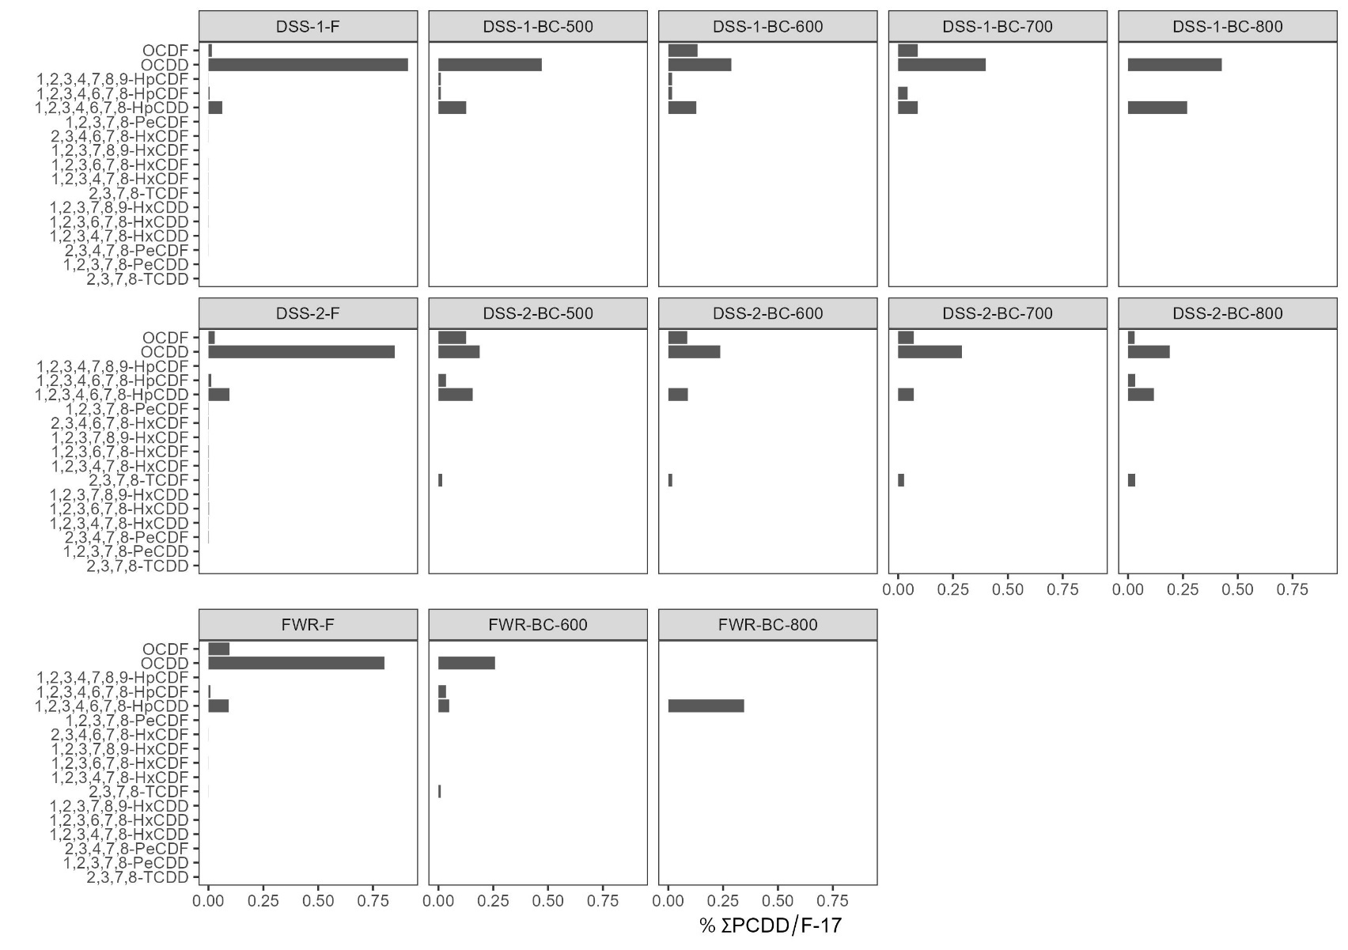

Figure 4 Distribution of PCDD/Fs (% of ∑PCDD/F-17) in the feedstock (F) and biochars (BC) at different temperatures (500-800 ˚C) for the digested sludge 1 (DSS-1), digested sludge 2 (DSS-2), and food waste reject (FWR).

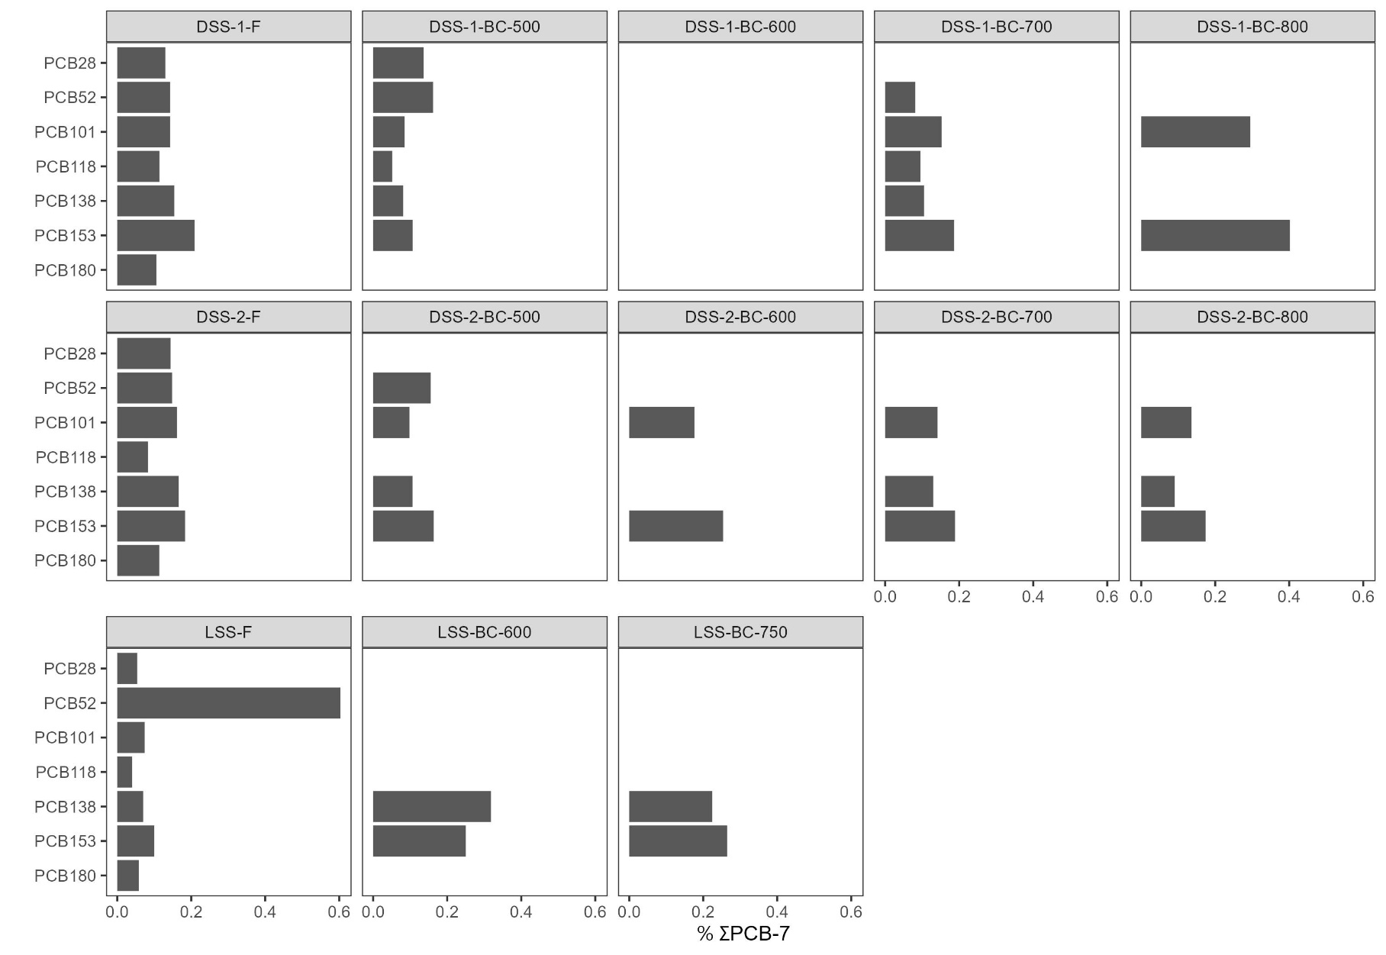

Figure S.5 Distribution of PCBs (% of ∑PCB-7) in the feedstock (F) and biochars (BC) at different temperatures (500-800 ˚C) for the digested sludge 1 (DSS-1), digested sludge 2 (DSS-2), and limed sludge feedstocks (LSS).

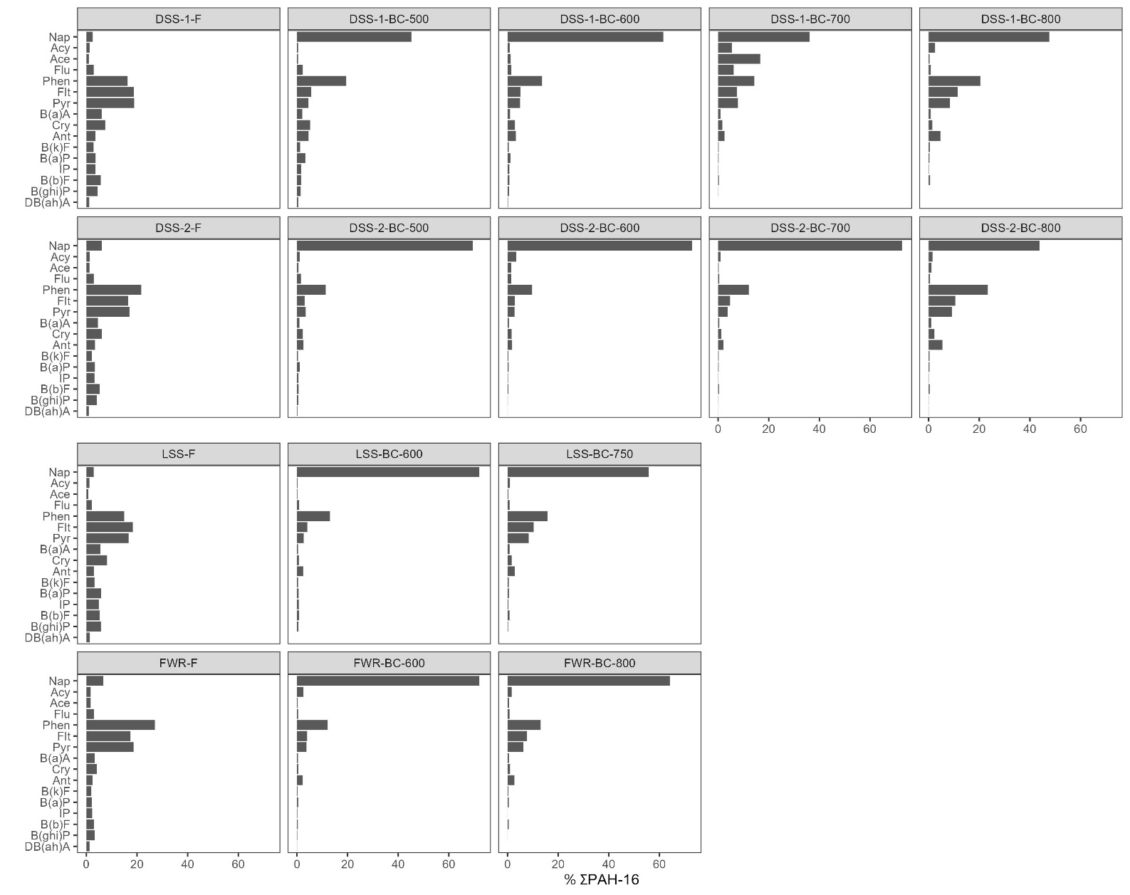

Figure S.6 Distribution of PAHs (% of ∑PAH-16) in the feedstock (F) and biochars (BC) at different temperatures (500-800 ˚C) for the sewage sludge and food waste reject samples.

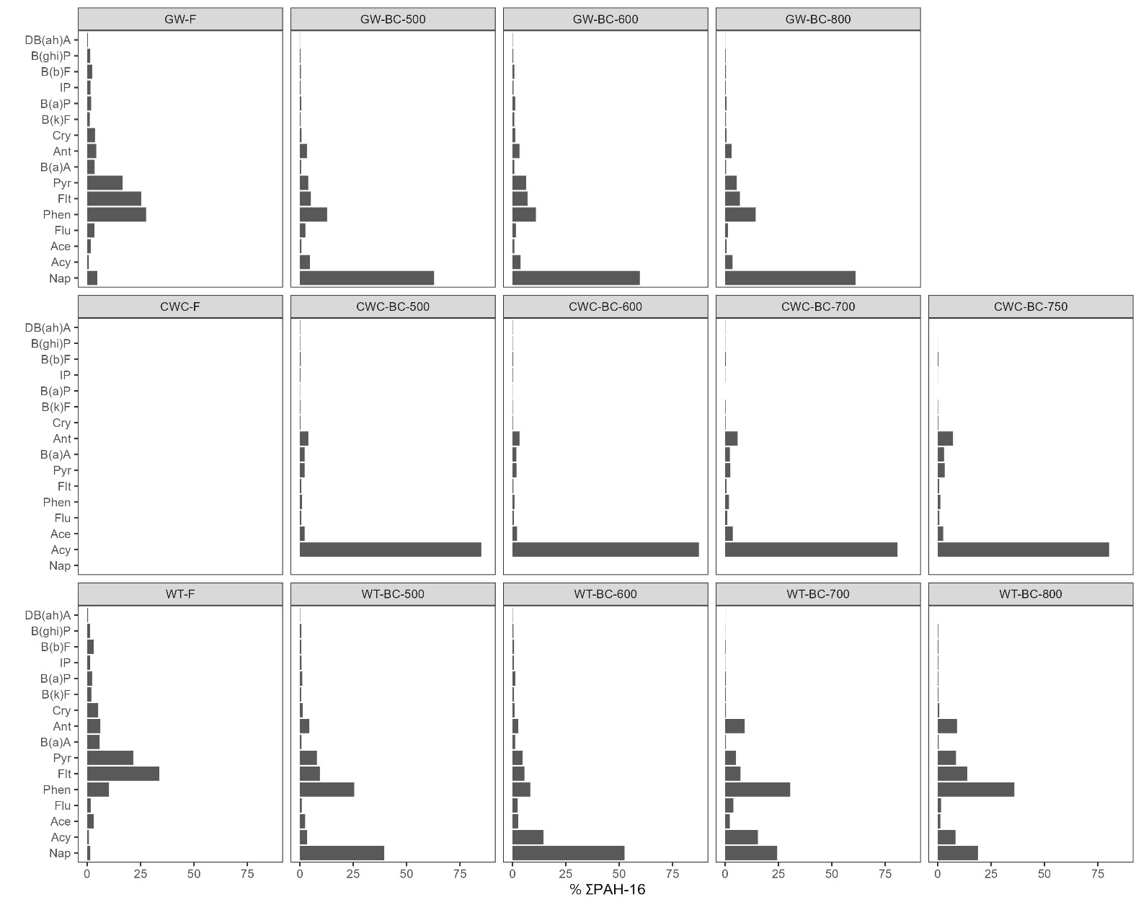

Figure S.7 Distribution of PAHs (% of ∑PAH-16) in the feedstock (F) and biochars (BC) at different temperatures (500-800 ˚C) for the wood-based samples

Table S.4 Total concentration of each pollutant class (PCDD/Fs, PAHs, and PCBs) in feedstock (F) and biochars. The feedstocks were measured standard deviations were conducted in triplicate measurements (n=3). (you have this in the main MS now.

|  |  |  |  |  |  |  |  |  |  |  |  |  |  |  |  |  |
| --- | --- | --- | --- | --- | --- | --- | --- | --- | --- | --- | --- | --- | --- | --- | --- | --- |
|  | **FWR** | | | **DSS-1** | | | | | **DSS-2** | | | | | **LSS** | | |
|  | **F** | **600** | **800** | **F** | **500** | **600** | **700** | **800** | **F** | **500** | **600** | **700** | **800** | **F** | **600** | **750** |
| **∑PAH**  **(mg kg-1)** | 323 ± 14 | 9.5 | 0.30 | 2011 ± 118 | 2.7 | 2.0 | 2.6 | 0.44 | 302 ± 6 | 3.3 | 2.9 | 3.2 | 2.7 | 58 ± 29 | n.d. | n.d. |
| **∑PCDD/F-17**  **(ng TEQ kg-1)** | 1.2 ± 0.1 | 0.1 | 0.003 | 8.3 ± 0.2 | 0.01 | 0.01 | 0.01 | 0.003 | 1.8 ± 0.1 | 0.03 | 0.02 | 0.03 | 0.03 | 3.0 ± 0.1 | n.d. | n.d. |
| **∑PCB-7**  **(µg kg-1)** | 9.2 ± 0.4 | n.d. | n.d. | 21 ± 1 | 1.70 | <LOQ | 1.3 | 0.26 | 7.6 ± 1 | 0.64 | 0.39 | 0.39 | 0.53 | 17 ± 1 | 0.25 | 0.24 |

Table S.5 PAHs and sum PAH-16 in CWC and DSS-1 condensate at different temperatures (mg kg-1). Add tables for PCDD/Fs and PCBs too

|  |  |  |  |  |  |  |  |  |  |
| --- | --- | --- | --- | --- | --- | --- | --- | --- | --- |
|  | **CWC** | | | | | | **DSS-1** | | |
|  | **500** | | **600** | **700** | **750** | | **600** | **700** | **800** |
| Naphthalene | 886 | 1130 | 1880 | 1690 | 361 | 3499 | 2190 | 2010 | 1390 |
| Acenaphthylene | 1560 | 2313 | 4260 | 4740 | 1160 | 5456 | 257 | 219 | 169 |
| Acenaphthene | 62.4 | 84.7 | 152 | 123 | 16.1 | 155 | 73 | 44 | 29.8 |
| Fluorene | 312 | 460 | 859 | 694 | 127 | 1403 | 470 | 303 | 223 |
| Phenanthrene | 178 | 224 | 480 | 456 | 118 | 1300 | 558 | 395 | 297 |
| Anthracene | 56.9 | 73 | 155 | 148 | 38.8 | 464 | 191 | 141 | 98.7 |
| Fluoranthene | 51.6 | 62.3 | 143 | 138 | 43.9 | 425 | 126 | 98.1 | 76.4 |
| Pyrene | 47.7 | 57.6 | 120 | 118 | 39.7 | 390 | 129 | 95.9 | 74 |
| Benz(a)anthracene | 22.6 | 28.1 | 55.2 | 47.1 | 19.1 | 162 | 96.1 | 73.6 | 56.9 |
| Chrysene | 19 | 24.1 | 47.1 | 40.2 | 20.9 | 135 | 145 | 127 | 82.9 |
| Benzo(b)fluoranthene | 8.25 | 9.82 | 22.8 | 18.2 | 11.1 | 60.9 | 26.8 | 22.1 | 17.7 |
| Benzo(k)fluoranthene | 6.65 | 7.44 | 18.4 | 14.6 | 9.61 | 46.9 | 14.4 | 12.1 | 8.65 |
| Benzo(a)pyrene | 15.5 | 18 | 41.2 | 34 | 19.6 | 121 | 36.2 | 28.9 | 22.5 |
| Indeno(1,2,3-cd)pyrene | 5.24 | 5.76 | 14.2 | 11.1 | 7.91 | 51.5 | 13.1 | 10.3 | 8.19 |
| Benzo(ghi)perylene | 3.87 | 4.14 | 10.3 | 8.89 | 7.58 | 40.3 | 9.15 | 7.03 | 5.41 |
| Dibenz(ah)anthracene | 1.64 | 1.94 | 4.42 | 3.41 | 2.17 | 12 | 5.91 | 3.89 | 2.98 |
| **Phase separation** | very low tar | much tar | very low tar | very low tar | very low tar | much tar | none | none | none |
| **∑PAH-16 (mg kg-1)** | **3237** | **4504** | **8263** | **8285** | **2002** | **13722** | **4341** | **3591** | **2563** |

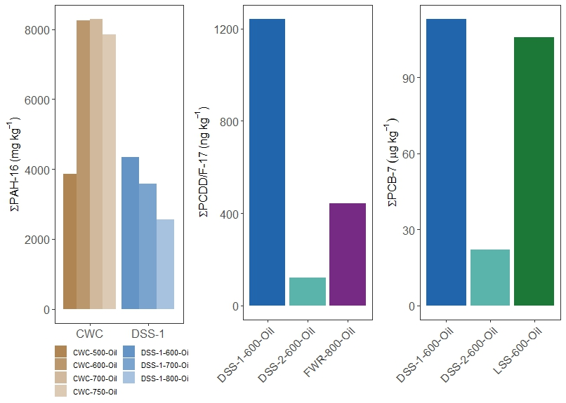

Figure S.1 Pollutant concentration in pyrolysis oil.

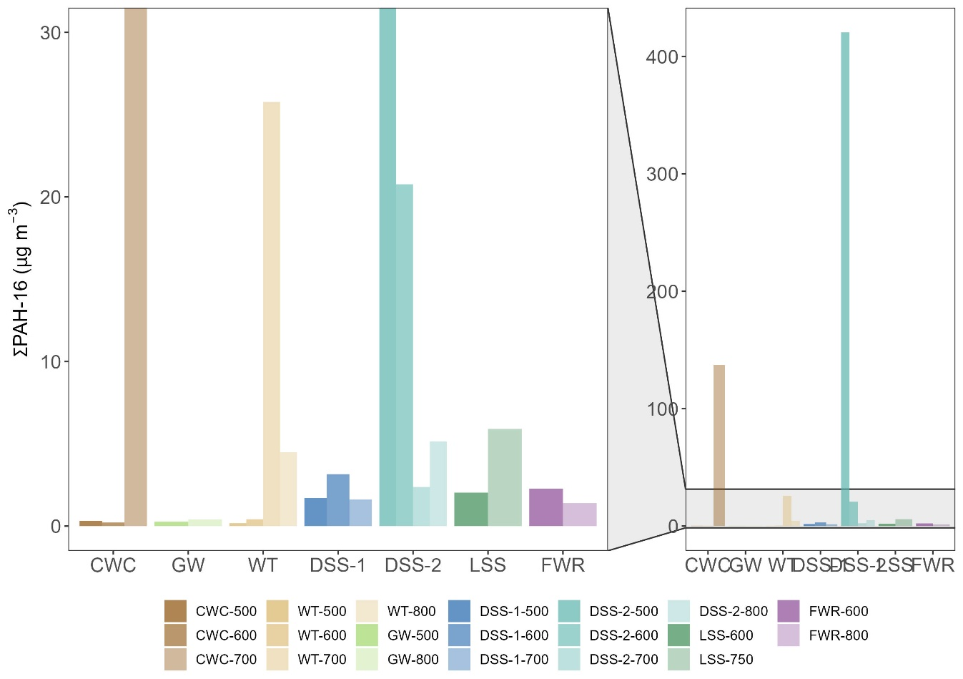

Figure S. 2 Pollutant concentration in exhaust

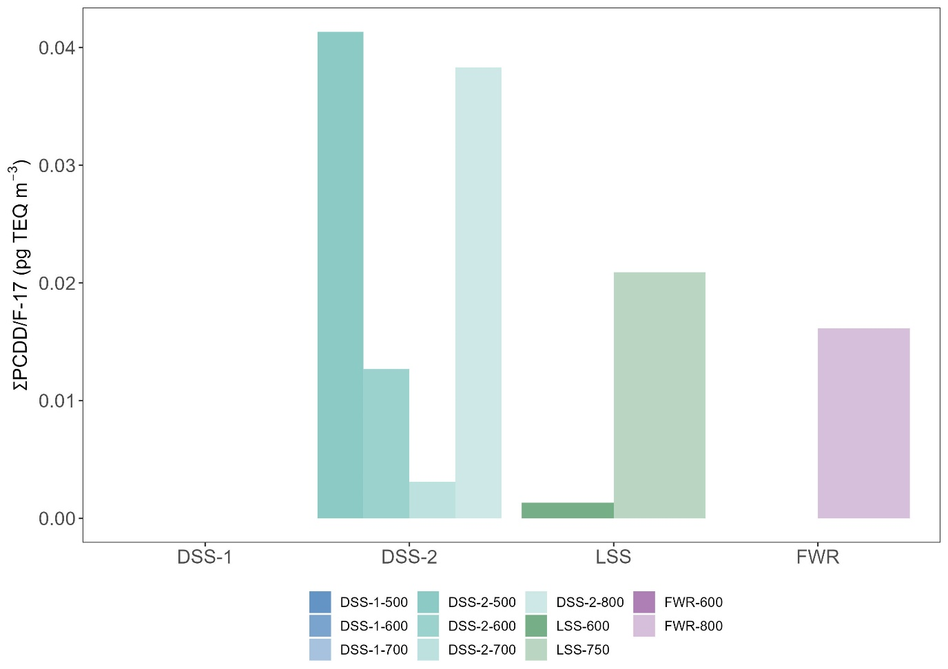

Table S.6 Chloride (Cl) content in feedstocks.

|  |  |
| --- | --- |
| **feedstock** | **Cl (g/kg)** |
| DSS-1 | 0.24 ± 0.01 |
| DSS-2 | 0.33 ± 0.08 |
| FWR | 2.57 ± 0.15 |
| GW | <LOD |
| LSS | 0.02 ± 0.03 |
| WT | 0.01 ± 0.01 |
| GW | <LOD |

Table S.7. Concentration of pollutants in pyrolysis oil.

|  |  |  |  |  |  |  |  |  |
| --- | --- | --- | --- | --- | --- | --- | --- | --- |
| **Feedstock** | **Pyr.**  **temp. ˚C** | **pollutant class** | **source** | **yield** | **Conc. (total)** | **Conc. (TEQ)** | **Conc. (yield corrected)** | **n() congeners detected** |
| CWC | 500 | PAH-16  (mg/kg) | wood | 0.31 | 3871±571 | 28±1.9 | 1191±176 | 16 |
| 600 | 0.32 | 8263 | 67 | 2627 | 16 |
| 700 | 0.27 | 8285 | 56 | 2204 | 16 |
| 750 | 0.13 | 7862±3990 | 107±73 | 1012±514 | 16 |
| DSS-1 | 600 | sludge | 0.22 | 4341 | 64 | 946 | 16 |
| 700 | 0.22 | 3591 | 51 | 801 | 16 |
| 800 | 0.21 | 2563 | 39 | 530 | 16 |
| DSS-1 | 600 | PCDD/F-17 (ng/kg) | sludge | 0.22 | 1241 | 50 | 270 | 15 |
| DSS-2 | 600 | 0.25 | 120 | 1.8 | 30 | 5 |
| FWR | 800 | reject | 0.22 | 442 | 16 | 99 | 9 |
| DSS-1 | 600 | PCB-7  (µg/kg) | sludge | 0.22 | 113 |  | 25 | 7 |
| DSS-2 | 600 | 0.25 | 22 |  | 5 | 7 |
| LSS | 600 | 0.21 | 106 |  | 22 | 7 |